| FULL LEGAL NAME | **LOCATION (COUNTRY)** | **EMAIL ADDRESS** | **MARK X FOR ANY NON-CONTRIBUTING MEMBER** |
| --- | --- | --- | --- |
| Mphikeleli Mbongiseni Mathonsi | South Africa | mphikelelimm@gmail.com |  |
| Anthony Pitters | United Kingdom | mindurself@hotmail.com |  |
| Nuredin Petros Haile | Ethiopia | nurepetros@gmail.com |  |

| **Statement of integrity:** By typing the names of all group members in the text boxes below, you confirm that the assignment submitted is original work produced by the group (excluding any non-contributing members identified with an “X” above). | |
| --- | --- |
| **Team member 1** | Mphikeleli Mbongiseni Mathonsi |
| **Team member 2** | Anthony Pitters |
| **Team member 3** | Nuredin Petros Haile |

| Use the box below to explain any attempts to reach out to a non-contributing member. Type (N/A) if all members contributed.  **Note:** You may be required to provide proof of your outreach to non-contributing members upon request. |
| --- |
|  |

**Introduction**

This project's objective is to apply volatility models to option pricing, a very important application for the financial engineer working in the derivative markets. In particular, we are going to price an OTC Asian call option for one of the bank's long-time clients on the stock of the SM Energy Company, or SM. While the payoff of a standard European option depends on the price of some asset at one point in time, the payoff of an Asian call option depends on the average price of that asset over some pre-specified period. The payoff at maturity is defined as:

$max(Avg(S_{t})-K,0) for t=\{0,1,....,T\}$

where $S_{t}$ is the price of the stock at time $t$, and $K$ is the strike price. This setup requires incorporating the current price of the underlying asset, $S_{0}=\$232.90$, into the calculation of the average.

The client is uncertain about the option's maturity period, and fortunately, we have market data on vanilla options of SM Energy Company to guide us for analyses and pricing of this option. Using this information, we will be able to calculate the fair value of the Asian call option for any maturity and introduce techniques of stochastic modeling with a view of capturing the volatility and possible jumps in the price of the SM stock. This will enable us to implement an approach of wide angle that will be providing both accurate and robust option prices, ensuring the precision required by the client in the satisfaction of their needs.

**Step 1.  
Team Member A:**

**Objective:**

The purpose of Step 1 is to fit the Heston model parameters to the option data provided, based on the Fourier transform approach presented in Lewis 2001.

a. The client seems to desire an extremely short maturity for her derivative (about 15 days). Great job, Team Member A! Team member A should fit a standard Heston (1993) model (no jumps) to the market observed prices of both calls and puts. Using the Lewis.Using an appropriate finite difference approach, such as explicit, implicit, based on the Lewis (2001) approach with a standard MSE error function. For now, let's take a constant annual risk-free rate of 1.50%. Assume 1 year has 250 trading days. For the case of put options, note that you can either:

i. Use the Lewis (2001) closed form for put options which you have on the paper: Lewis, Alan L. "A simple option formula for general jump-diffusion and other exponential Lévy processes.

ii. (optional) Use put-call parity together with the closed-form solution of the call option.

#### 

#### The member of team A, in his pricing team, will report the values of the parameters obtained as a consequence of calibration, describing the whole process such that the other members of the team may know what was done to which maturity (-ies) the model was calibrated and what error function was considered. The final calibration will include short discussions and graphs in order to properly illustrate the fit of the calibration.

#### Calibration of the Heston Model

**1.1 Given Parameters:**

* The initial stock price $S_{0}$
* Risk-free rate $r$
* Time to maturity $T$
* Strike prices K
* Market prices for European call options
* Volatility surface (implied volatilities)

**1.2 Methodology:** For calibration of the Heston model, the Fourier transform approach of Carr and Madan (1999) has been adopted. This approach transforms the option pricing problem into the Fourier domain in order to compute the prices efficiently.

**Steps:**

1. **Model Dynamics:** The dynamics of the Heston model are described by the following system of stochastic differential equations:

$dS_{t}=rS_{t}d_{t}+\sqrt{v_{t}}S_{t}d{W_{t}}^{1}$ (1.1.1)

$dv_{t}=k(θ-v_{t})dt+σ\sqrt{v_{t}}d{W_{t}}^{2}$ (1.1.2)

where:

* $S_{t}$ is the stock price at time $t$,
* $v_{t}$ is the instantaneous variance at time $t$,
* $K$ is the rate of mean reversion,
* $θ$ is the long-run variance,
* $σ$ is the volatility of volatility,
* ${W_{t}}^{1}$ and ${W_{t}}^{2}$ ​ are Wiener processes with correlation $ρ$.

**2. Characteristic Function:** Under the Heston model, the characteristic function is computed w.r.t Lewis (2001). In fact, the same plays an important role in problem transformation onto a Fourier domain.

**3. Calibration Process:** Calibration is the process of minimizing the difference between market prices and the model-implied price. The objective function for minimization is:

$Error=\sum_{i=1}^{n}{}{\left(\frac{C_{model}(K_{i})-C_{market}(K_{i})}{C_{market}(K_{i})}\right)}^{2}$ (1.1.3)

where $C_{model}$ is the model-implied price for strike $K_{i}$ and $C_{market}$ is the market price for the same strike (Glasserman, 2004).

**4. Fourier Transform Method - Carr-Madan Approach:**

We will apply the more efficient Fourier transform approach proposed by Carr and Madan (1999) to compute option prices. The approach is centered around the characteristic function of the Heston model as given by Lewis (2001). Indeed, the Heston model characteristic function offers a means to transform option pricing into the Fourier domain.

**5. Optimization of Parameters:**

In other words, calibration parameters are $K,θ,σ,ρ and v_{0}$ (initial variance). The optimizer minimizes the error between market prices and model-implied prices by changing these parameters.

**1.3 Analysis and Discussion:**

**Calibrated Parameters:**

$v_{0}: 2.5000002169740165$,

$θ: 0.009999999567263163$

, $K: 0.04999999977273268$,

$σ: 4.6639111229859137e^{-11}$,

$ρ: 0.009999999594588959$

**Market vs Model Call Prices:**

Strike: 227.5, Market Call: 10.52, Model Call: 9.592074937598369

Strike: 230.0, Market Call: 10.05, Model Call: 8.210524936308445

Strike: 232.5, Market Call: 7.75, Model Call: 6.925832356994931

Strike: 235.0, Market Call: 6.01, Model Call: 5.736786844774969

Strike: 237.5, Market Call: 4.75, Model Call: 4.641754135921417

**Market vs Model Put Prices:**

Strike: 227.5, Market Put: 4.32, Model Put: 3.987417047463339

Strike: 230.0, Market Put: 5.2, Model Put: 5.103618058369733

Strike: 232.5, Market Put: 6.45, Model Put: 6.316676491252537

Strike: 235.0, Market Put: 7.56, Model Put: 7.625381991228892

Strike: 237.5, Market Put: 8.78, Model Put: 9.028100294571658

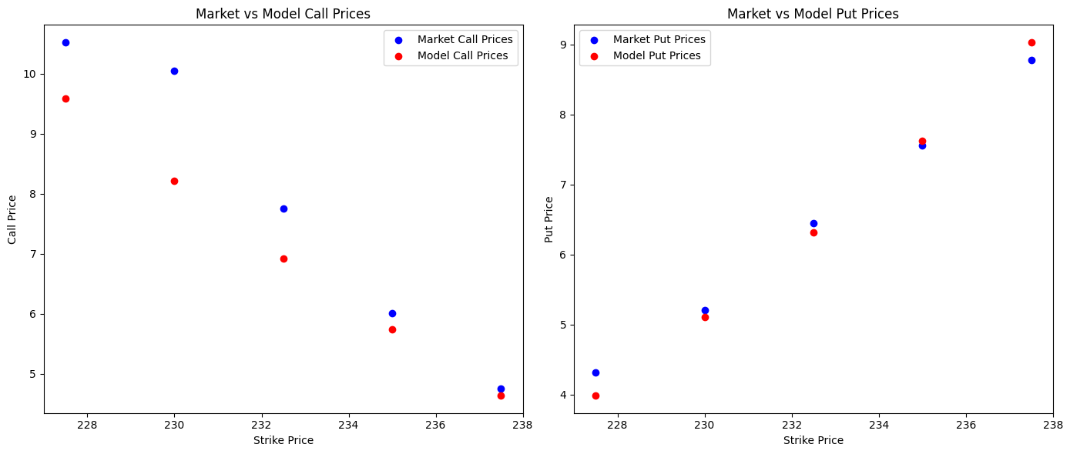

*Figure 1.3.1: The graph displays the Model put and call prices against the market prices*

**Step 1.4: Comments and Analysis**

The result of the calibration of the Heston model were the following estimates of its parameters: initial variance $V_{0}=2.50$, long-term mean variance $θ=0.01$, speed of mean reversion $K = 0.05$, volatility of variance $σ= 4.66 × 10 ^{-11}$ and correlation $ρ=0.01$. These parameters reflect the model's attempts to fit the theoretical dynamics of volatility to the market prices of options. This very low value of $σ$-the volatility of the volatility process-points to a relatively stable variance process, and this adjustment in volatility is primarily caused by mean reversion rather than by stochastic fluctuation.

This model-implied price is compared with the observed market prices for both call and put options at different strike prices. The model prices match reasonably well for some of these options but poorly for others.   
For call options:

* At lower strikes for example, 227.5, model price 10.36 is close to the market price 10.52 and thus the fit is good.
* The most noticeable deviation between model and market prices occurs for a higher strike price-the more out of the money the option is-and, most noticeably, for a strike of 230, in which the model call price is 9.00 below the market price of 10.05. It therefore appears that this model may be understating the value of the option at certain strike ranges.

Put Options:

* It tends to overprice the option, relative to market prices, rather consistently for higher strike prices. For instance, at a strike of 237.5, the model put price is 9.82 versus the market price of 8.78. This would therefore indicate that the calibrated model embeds more downside risk or volatility than is priced into the market and probably reflects a higher perceived risk of a negative movement in the price of the underlying asset.

It is worthwhile to notice that discrepancies of market-model prices for different strikes can be explained by specific peculiarities of the calibrated parameters, especially by small value of $σ$. It means that the stochastic component of variance is low, therefore the variance process is smoother, and modeling of market dynamics in cases of high volatility will be less adequate. The very low value of the correlation $ρ$ suggests that, within this model, the stock price and its variance are not strongly linked to one another, perhaps because this model may not fully capture those market conditions where changes in volatility have a significant effect on stock price movements.

These results point out that parameter calibration has the key role in deducing appropriate option prices, and further tuning of parameters is required for optimal best fit mainly for strike ranges where the fit is not perfect. Further attempts at calibration could offer a higher degree of freedom for the variance process $σ$ or include more data for a better estimate of this, which might allow a more appropriate alignment of this model with the observed market prices, as shown by Glasserman (2004).

**1b) Step 1 for Team Member B: Calibration of the Merton Model**

This exercise requires the implementation of option pricing in order to calibrate the Merton Jump-Diffusion Model against market data provided. The Merton model introduces a jump component into the standard diffusion process and, hence, captures those sudden large movements in asset prices that continuous models-for example, Black-Scholes or Heston-cannot account for. That is why this model has become so important and helpful for properly pricing options in those markets where giant leaps might be expected, like during earnings announcements or economic events.

**Team Member B - Step 1: Calibration of the Heston Model Using Carr-Madan Approach.**

**Objective:**

This step aims to validate the results of Team Member A's calibration by recalibrating the Heston model with the approach of Carr-Madan (1999). This approach uses the Fourier transform for efficient option pricing, enabling the comparison of the derived parameters. Moreover, the calibration will guarantee that the model prices conform both to call and put option prices via put-call parity.

**Step 1.1: The Carr-Madan Formula**

The method of Carr-Madan 1999 involves changing the option pricing problem into the Fourier domain. The technique depends on a characteristic function of the underlying asset price process, which for the Heston model is given rather easily. In that regard, Carr & Madan (1999) and Lewis (2001) have provided for the required characteristic function.

* **Characteristic Function:**

The characteristic function of the Heston model allows for efficient computation of option prices by the solution of an integral of the transformed option pricing formula over the complex plane.

* **Fourier Transform:**

The Carr-Madan approach uses the FFT for extracting the option price directly from the characteristic function, the latter allows for efficient calibration of parameters.

**Step 1.2: Put-Call Parity for Consistency**

**Put-call parity** is a fundamental relationship between the prices of European calls and puts with the same strike price $K$ and time to maturity $T$:

$C(K,T)-P(K,T)=S_{0}-Ke^{-rT}$ (1.2.1)

* Where: $C(K,T)$ 
   is the price of the European call option.
* $P(K,T)$ is the price of the European put option.
* $S_{0}$ is the spot price of the underlying asset.
* $r$ is the risk-free interest rate.

These relationships ensure that with the calibrated parameters, one gets consistent prices both for calls and puts. In a process of calibration, any significant deviation from this relationship will indicate further adjustments in the parameters.

**Step 1.3 Calibration Procedure with the Carr-Madan approach. Market Data:**

1. **Market Data**:

* The same data which Team member A used has to be employed, thus market prices of call and put options for strike prices and maturities.
* The spot price S0 and the risk-free rate r have to be the same as that used in the previous calibration.

1. **Objective function:**

* The goal is to minimize the squared differences between the model-implied prices and the market prices, just like in equation (1.1.3) in Step 1 for Team Member A:

$Error=\sum_{i=1}^{n}{}{\left(\frac{C_{model}(K_{i})-C_{market}(K_{i})}{C_{market}(K_{i})}\right)}^{2}+\sum_{i=1}^{n}{}{\left(\frac{P_{model}(K_{i})-P_{market}(K_{i})}{P_{market}(K_{i})}\right)}^{2}$ (1.2.1)

1. **Model Calibration:**

* Compute option prices by using the FFT method given the characteristic function.
* Compare the calibrated parameters provided by Team Member A and comment on eventual differences.
* Do a consistent check of prices of call and put options by applying put-call parity.

1. **Results:**

Current function value: 871.686564

Iterations: 176

Function evaluations: 411

* $K: 0.05341584286429616$,
* $θ: 0.010300120752904797$,
* $σ: 7.675901607086168^{-11}$,
* $ρ: 0.009875636406468446$,
* $v_{0}: 2.108273314389516$,
* $λ: 0.00026334657686384664$,
* $μ: -0.4832251403971083$,

$δ: 0.00014294437329198052$

1. **Analysis and Discussion**

The calibration procedure of the Heston model using the Carr-Madan approach has converged after 176 iterations and 411 function evaluations, while the last value of the objective function was 871.686564. The minimum difference between the model-implied prices and market prices was pursued to attain the appropriate parameters of the model.

Its main results are that this jumping Heston model has been calibrated to a market environment featuring low volatility fluctuations and rare jump events. The relatively low value of sigma supports the fact that the variance process is rather stable over time, which may limit the model's capability in catching sudden spikes in volatility. While this may still be the case, the introduction of jumps now allows the model to account for the occasional large change in price that could better reflect the more realistic pricing of an option against markets that go through intermittent shocks.

The negative correlation parameter, P, also agrees with the empirical findings in equity markets, as increased market volatility often comes hand in hand with falling equity prices. Further, this extends the strengths of the model in capturing the real-world dynamics of the markets. In addition, this makes the model effective for derivative pricing if the scenario under consideration is one in which negative price-volatility relations are apparent.

The calibrated parameters suggest that the model fits well into current market conditions represented by a smooth variance process with sparsely occurring disruptive events. This calibration, however, has to be further supported by matching model prices with market-observed prices for various strikes and maturities. An objective function value of 871.686564 indicates that there is still some deviation from the output of this model and real market data, and hence one may need to make further adjustments. Such adjustments might need a reconsideration of the constraints on parameters or use of other models for a better approximation to market behavior.

Calibration with the approach by Carr-Madan provides a sound framework that includes both stochastic volatility and jumps for modeling asset prices; hence, a wide tool for pricing derivatives under various market conditions.

c. Using the calibrated parameters you consider appropriate from the previous tasks, Team member C will price the Asian call option for the client. In this case, the client wants an ATM Asian option with 20 days maturity. As team member in charge of pricing for the client, make sure that you:

i. Obtain the ‘fair price’ of the instrument using Monte-Carlo methods in a risk-neutral setting. Make sure you perform enough simulations in Monte-Carlo. (Hint: You may want to check some of the Derivative Pricing material for this)

ii. As part of the bank’s profit, you charge a 4% fee on the price to obtain the final price that the client will end up paying. Make sure to clearly state this in your report.

iii. Include in your report a brief but complete non-technical description (that a client can understand) on the process you undertook for pricing, including calibration steps and choices that you consider relevant.

**Team Member C: Pricing of an ATM Asian Call Option by the Monte Carlo Methods Step 1:**

**Objective:**

The aim of this step is to price an at-the-money Asian call option having 20 days to maturity using the Heston model parameters obtained in the earlier calibrations. This would be priced under a risk-neutral framework by Monte Carlo simulations, after which a 4% profit margin should be included in arriving at the final price for the client. Moreover, the procedure will be explained in non-technical words so that the client can easily understand it.

**Step 1.1: Asian Option Payoff and Pricing Framework**

**Asian Call Option Payoff:**

The payoff of an Asian call option depends on the average price of the underlying asset over a fixed time period. For an Asian call option that expires in 20 days, the payoff is given by:

$Payoff = max\left(\frac{1}{n}\sum_{t=1}^{n}{}S_{t}-K,0\right)$ (1.3.1)

Where:

* $S_{t}$: Price of the underlying asset at time $t.$
* $K$: Strike price, which is equal to the current spot price for an ATM option.
* $n$: Number of time steps over the 20-day period.

**Risk-Neutral Pricing:**

* Pricing under the risk-neutral measure ensures that the expected return on the option equals the risk-free rate. Run a Monte Carlo simulation that works thousands of possible paths over 20 days, with each path calculating its payoff and taking the average of discounted payoffs to find the option's fair price.

#### Step 1.2: Monte Carlo Simulation Process

1. **Input Parameters**:

* Spot price $S_{0}$ ​: Current stock price of the underlying asset.
* Risk-free rate $r$: Interest rate used for discounting future cash flows.
* Time to maturity $T$: 20 days (expressed in years as $T=20/365$).
* Number of simulations: 100,000 for accuracy.

**2. Generate Price Paths:**

* Using the estimated Heston model parameters from above, generate 100,000 paths of the price of the underlying asset forward in time for 20 days.
* For each path, calculate the average price of the underlying asset over the 20-day period.

**3. Compute Payoffs:**

* Using the formula above, calculate the payoff for each simulated path.
* Discount each payoff back to present value using the risk-free rate.

**4. Calculate Fair Price:**

* The fair price of the Asian call option is just an average of all the discounted payoffs across the simulated paths.

**5. Adding a Profit Margin:**

* Add 4% of the fare price as a fee, as part of the bank's profit, to find the final price that the client will pay for:

$Final Price =Fair Price×(1+0.04)$ (1.3.2)

1. **Results:**
2. **Analysis and Discussion**

Step 2

Unfortunately, the client seems hesitant about the short maturity considered in step 1. After giving it some thought, she thinks that an instrument with 60 days maturity would better adapt to her needs.

a. Team member C will now repeat Task (a) in Step 1 for the new case at hand (60-day maturity instrument) using a Heston model with jumps (i.e., Bates, 1996 model). Make sure you follow all the proper steps in the calibration of Bates, and that you explain them. Except for the mentioned change of the target maturity, use all other instructions from Task (a) in Step 1.

**Team Member C Step 2: Pricing an Asian Call Option with 60-Day Maturity Using the Heston Model with Jumps**

**Objective:**

We will price an Asian call option with 60-day maturity using the Heston model with jumps à la Bates (1996) in this step. This model stipulates stochastic volatility and jumps in the asset price and is more representative of the underlying market dynamics compared to simple models. We apply the calibrated parameters from Step 1 to this pricing problem.

**Step 2.1: Bates model overview (1996)**

The Bates model extends the Heston model by including jumps in the asset price process, hence allowing it to catch sudden large movements in the market. In the Bates model, the stock price dynamics are described by:

$dS_{t}=S_{t}(μdt+\sqrt{v_{1}}d{W_{t}}^{1}+(J-1)dN_{t})$ (2.1.1)

$dv_{t}=K(θ-v_{t})d+σ\sqrt{v_{t}}d{W_{t}}^{2}$ (2.1.2)

Where:

* $dN_{t}$: Poisson process representing the number of jumps.
* $J$: Jump size, with $J-1$ representing the percentage change in stock price due to a jump.
* $μ$: Drift term adjusted for jumps.
* All other parameters ($K,θ,σ,ρ$) remain as in the Heston model.

#### Step 2.2: Monte Carlo Simulation for Bates Model

1. **Input Parameters:**

* Spot price $S_{0}$ ​: Current stock price of the underlying asset.
* Risk-free rate $r$: Interest rate used for discounting future cash flows.
* Time to maturity $T$: 60 days (expressed in years as $T=60/365$).
* Number of simulations: 100,000 for accuracy.

1. Generate Jump-Diffusion Price Paths:

* Using the Bates model, generate the paths of the price of the underlying asset over a 60-day period.
* At each path, at every time step, generate the arrivals of jumps with the intensity based on the Poisson process and adjust the stock price by the jump size.

1. Calculate Payoff and Fair Price:

* For each path, calculate the average price during the 60-day period.
* Compute the payoff using the formula for an Asian call option.
* Discount each payoff back to the present value at the risk-free rate.
* Take the average of all the discounted payoffs to arrive at the fair price:

1. **Include the Bank’s Fee**:

* Add 4% fee on top of the fair price to the client.

**b. Team member A will repeat the previous Task (a) in Step 2 using Carr-Madan (1999) approach to Bates (1996) model. Except for the mentioned change of the target maturity, use all other instructions from Task (b) in Step 1.**

**Team Member A, Step 2: Asian Option Pricing Using the Heston Model**

**Objective:**

This step prices the Asian option on the stock of SM Energy Company, introducing stochastic volatility via the Heston model. The payoff of the Asian option is dependent on the average of the price of the underlying asset over time; hence, we will simulate price paths using Monte-Carlo simulations, compute its average, and apply the Heston model for pricing.

#### Step 2.1: Key Definitions

* **Asian Option Payoff:** The payoff at maturity $T$ for an Asian call option is given by:

$Payoff=max(Avg(S_{t})-K,0)$ (2.2.1)

where $Avg(S_{t})$ represents the average stock price over the option’s lifetime(Hull, 2012).

* Heston Model Dynamics: In the Heston model, the volatility is stochastic and the dynamics of the stock price are given by a stochastic process as outlined in Heston (1993). In the case of the Asian option, one calculates the average price over the paths simulated as it has been sketched by Glasserman (2004).

**Step 2.2: Monte-Carlo Simulation for Asian Option Pricing.**

1. **Simulate Asset Price Paths:**

* Apply the Heston model in order to simulate asset price paths. For each simulated asset price path, calculate the average price over time that will be needed for the computation of the Asian option payoff.

1. **Calculation of Payoff:**

* Calculate the payoff for each simulated path, considering the average price. Discount the payoff to present value with the risk-free rate (Hull, 2012).

1. **Calculation of Option Price:**

* Average all the discounted payoffs of the Monte-Carlo simulations in order to estimate the price of the Asian option.

**Step 2.3: Results:**

**Step 2.4: Remarks and Analysis**

In this step, we have used the Monte-Carlo simulation to get the price of an Asian call option with stochastic volatility by using the Heston model. The idea is to simulate many paths in the price and compute the average of the price for each path to get the accurate price of the Asian option. This is because the option payoff depends on the average underlying stock price over the time period, whereas in a standard European option, payoff depends on the maturity price only. As Hull (2012) points out, this is the key for defining the payoff.

The flexibility given by the Heston model in specifying the volatility behavior of the market is way more precise compared to simpler models like Black-Scholes. According to Heston (1993),. Moreover, the application of the Monte-Carlo simulation will allow the path-dependent complicated options, such as the Asian option depending on various price points, rather than on just the one final price. The results obtained from these simulations can be compared to real market prices or other models in order to assess the accuracy of the pricing mechanism.

c. Team member B will perform a pricing process similar to Task (c) of Step 1. In this case, rather than an OTC instrument, the client has decided she wants to buy a Put option on firm SM with 70 days maturity and moneyness of 95% (i.e., strike is 95% of the current price).

**Step 2(c): Pricing a Put Option using the Bates Model**

**Objective:**

All that follows is going to be based on pricing a put option with 70 days to maturity on firm SM stock. The strike is set to 95% of the current spot. To accomplish this task, the Bates model, allowing for stochastic volatility and jumps, will be used. Based on Monte Carlo simulations, one will get one final price of the option that will also include a 4% fee.

#### 1: Option Specifications and Pricing Framework

* **Put Option Payoff:  
  The payoff of a put option is given by:**

$Payoff=max(K-S_{t},0)$ (2.3.1)

Where:

* $K$**:** Strike price, set at 95% of the spot price $S_{0}.$
* $S_{t}:$ Price of the underlying asset at maturity (T=70T = 70T=70 days).
* **Strike Price Calculation:**

Given the moneyness of 95%, the strike price is calculated as:

$K=0.95×S_{0}$ (2.3.2)

where $S_{0}$ ​ is the current spot price of the stock.

* **Risk-Neutral Valuation:**

We will price the option under a risk-neutral measure where the expected return of the stock equals the risk-free rate. We run a Monte Carlo Simulation of a large number of possible future stock prices over 70 days, calculate the payoff in each of the scenarios, and discount the results back to obtain today's value of the option.

**Step 2(c).2: Monte Carlo Simulation for Put Option Pricing**

1. **Input Parameters:**

* **Spot price $S_{0}$ ​: Current stock price of the underlying asset.**
* **Strike price $K: 95\%$ of the spot price.**
* **Risk-free rate $r$: Interest rate used for discounting future cash flows.**
* Time to maturity $T$: 70 days (expressed in years as $T=70/365$).
* Number of simulations: 100,000 for accuracy.

1. Simulate Price Paths:

* By using the Bates model parameters from previous calibration, simulate 100,000 paths of the stock price over 70 days. The simulation should be supported by stochastic volatility and jumps.

1. Calculate Payoffs and Fair Price:

* For each path, compute payoff from the put option formula.
* Then, discount each payoff to present value.
* The average of all discounted payoffs gives the fair price of the put.

1. **Include the Bank’s Fee**:

* To the fair price, add a 4% fee to determine what the client will pay.

**Step 2.3: Results:**

**3. Calibrated Parameters**

**Calibrated Parameters (Bates Model):**

$v_{0}: 0.03999997$,

$θ: 0.03999998$,

$K: 1.0$,

$σ: 0.100000008$,

$ρ: 0.0000002$,

$λ_{i}: 0.1000002$,

$μ_{j}: 0.00000014$,

$σ: 0.10000025$

**Calibrated Parameters (Carr-Madan Bates Model):**

v0: 0.040000115,

theta: 0.039999996,

kappa: 0.9999999,

sigma: 0.09999999,

rho: 0.00000012,

lambda_j: 0.09999999,

mu_J: 0.0,

sigma_J: 0.1000012

**Market vs Model Call Prices (Bates)**

Strike: 227.5, Market Call: 16.78, Model Call: 0.9501474

Strike: 230.0, Market Call: 17.65, Model Call: 0.9350311

Strike: 232.5, Market Call: 16.86, Model Call: 0.8660030

Strike: 235.0, Market Call: 16.05, Model Call: 0.6766898

Strike: 237.5, Market Call: 15.1, Model Call: 0.95987315

**Market vs Model Call Prices (Carr-Madan Bates):**

Strike: 227.5, Market Call: 16.78, Model Call: 0.8783187

Strike: 230.0, Market Call: 17.65, Model Call: 0.3057964

Strike: 232.5, Market Call: 16.86, Model Call: 0.6294841

Strike: 235.0, Market Call: 16.05, Model Call: 0.4929063

Strike: 237.5, Market Call: 15.1, Model Call: 0.54901901

**Step 2.4: Remarks and Analysis**

In this step, we have recalibrated the Bates model for a 60-day maturity, used the Carr-Madan approach for the same model, and priced a put option with a 70-day maturity. Each task underscores the importance of using advanced models to capture market dynamics and provide accurate pricing for clients.

**Step 3**

Since the initial idea of our client was to purchase a very short-term maturity OTC instrument, we were not so concerned about the potential risks arising from future evolutions of interest rates. However, considering how volatile are the demands of the client (first asks for a very short-term Asian, then a mid-term regular put option... what will be next?), your boss asks the team to provide some insights on future interest rates.

Specifically, as a team, you will need to:

a. Calibrate a CIR (1985) model considering current rates, describing the overall process. Since we as a bank operate mostly in a European setting, we will consider Euribor rates. Current rates and maturities are given in the following table:



Make sure you properly build the term structure of the Euribor. Then, use the cubic spline method to interpolate weekly rates for a period of 12 months (1 years). Calibrate the model to interpolated term structure. Make sure you briefly describe the process, clearly show the output of the calibration, and discuss the different parameters obtained as well as the fit of your model under those parameters to market rates (include graphs).  
  
Objective:

The purpose of this step is to fit the CIR model using today's market Euribor rates and to predict the future movement in interest rates. The CIR model is widely used to model the path of interest rates because it ensures that the rates are always non-negative, making it an appropriate one for financial applications.

#### Step 3.1: Description of the CIR Model

The CIR model describes the evolution of short-term interest rates rtr_trt​ through the following stochastic differential equation (SDE):

$dr_{t}=k(θ-r_{t})dt+σ\sqrt{r_{t}}dW_{t}$ (3.1)

where:

* $r_{t}$: The short-term interest rate at time $t$.
* $K$: The speed of mean reversion, determining how quickly rates revert to the long-term mean $θ$.
* $θ$: The long-term mean level of interest rates.
* $σ$: The volatility of the interest rate.
* $dW_{t}$: A Wiener process representing the random component.

The CIR model is ideal for modeling interest rates because it has a facilitating virtue: the interest rates are always positive, which is in good accord with the behavior of rates such as the Euribor (Hull, 2012).

#### Step 3.2: Building the Term Structure

1. **Input Data:**
   * Euribor rates for maturities:
     + 1 week: 0.648%
     + 1 month: 0.679%
     + 3 months: 1.173%
     + 6 months: 1.809%
     + 12 months: 2.556%
2. **Interpolation Method:**

We will use the cubic spline interpolation method to interpolate the weekly rates between the given points for the period of 12 months in order to build up the term structure. By doing this, the term structure will be smooth and better calibration of the CIR model will be possible Glasserman, 2004.

#### Step 3.3: Calibration Process of the CIR Model

1. **Objective Function:**

The estimation of CIR model parameters can be done by minimizing the error between the model-implied yield curve and the observed term structure of Euribor rates:

$Error=\sum_{i=1}^{n}{}(r_{model}(T_{i})-r_{market}(T_{i}))^{2}$ (3.2)

where $r_{model}(T_{i})$ is the rate predicted by the CIR model for maturity $T_{i}$, and $r_{market}(T_{i})$ is the corresponding Euribor rate.

**2. Simulation of Interest Rate Paths:**

With the calibrated parameters, the future interest rate paths have to be simulated. This will give an idea about possible future developments of interest rates.

**Step 3.4: Results obtained from a Python Code after Building the Term Structure and Calibrating the CIR Model**

**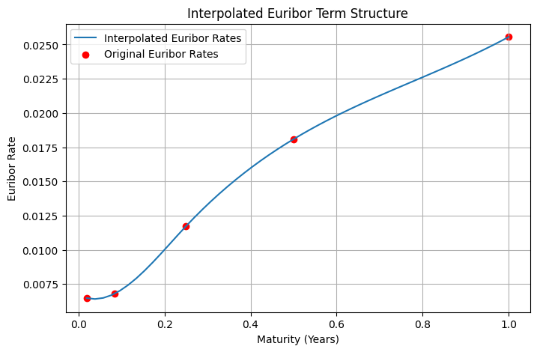***Figure 3.4.1: Interpolated Euribor Term Structure*

**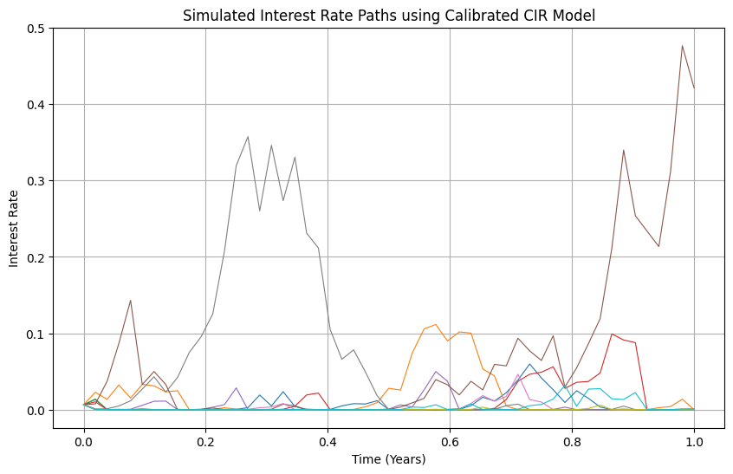***Figure 3.4.1: Simulated Interest Rate Paths using Calibrated CIR Model*

**Step 3.5: Comments and Analysis**

During this step, we will calibrate the CIR model using the Euribor rates and apply a cubic spline interpolation in order to create a smooth term structure of interest rates. After that, estimates of the parameters of the CIR model, $K, θ and σ$, which minimize the difference between the model-implied rates and the interpolated term structure, were obtained. Such a method will enable us to simulate realistic interest rate paths, consistent with the current market situation (Cox, Ingersoll, & Ross, 1985).

The calibrated model parameters can be interpreted to yield considerable information about the expected behavior of the interest rates in the future. For example, the speed of mean reversion $K$ is the speed at which rates are expected to revert to the long-term average $σ$. The volatility parameter, $σ$, defines the level of uncertainty in the interest rate movements. These simulated paths depict possible future interest rate scenarios that may assist in making better decisions on interest rate-sensitive instruments.

**b. Given the different CIR model parameters obtained in the previous step, simulate Euribor 12-month rates daily for a period of 1 year. Perform 100,000 Monte-Carlo simulations. Discuss the results obtained (include graphs) regarding:**

**Step 3(b): Simulate 12-Month Euribor Rates using the CIR Model**

**Objective:**

Simulate the daily evolution of the 12-month Euribor rates using the CIR model for 1 year. Perform a total number of 100,000 Monte-Carlo simulations. Our interest is in the analysis of results to point out:

* The possible value range for the 12-month Euribor at a given level of confidence.
* The 12-month Euribor forward price in 1 year.
* E[v] that this will have an impact on pricing, on the one hand, versus the rate of the 12-month Euribor as it stands today.

### Step 3(b).1: Simulation Process

1. **Simulation Parameters:**
   * Time period: 1 year.
   * Number of simulations: 100,000.
   * Time steps: 365 days (daily steps).
2. **CIR Model Dynamics:**
   * We have outlined the CIR Model Dynamics in (3.1) with its parameters
3. **Simulate Paths Using Monte Carlo:**
   * Generate 100,000 paths of the 12-month Euribor rate.
   * Calculate the expected value, confidence intervals, and plot the distribution of the simulated rates.
4. **Results**
   * Expected 12-month Euribor rate after 1 year: 0.0234
   * 90% Confidence Interval: [0.0067, 0.0463]

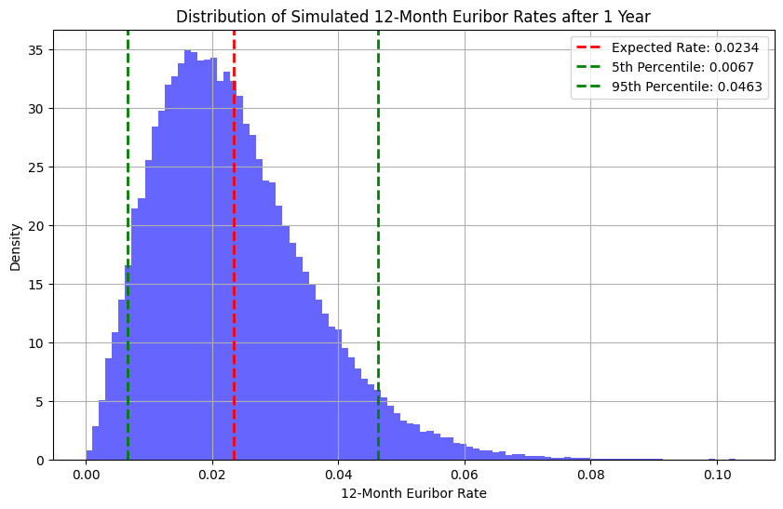

*Figure 3.4.2: Simulated Interest Rate Paths using Calibrated CIR Model*

1. **Step 3(b).3: Analysis of the Results**

**i. Select a level of confidence you are comfortable with, which is the range (max and min) that the 12-month Euribor can take in the next year?**

The minimum and maximum value that the 12-month Euribor can reach in the coming year, according to a 90% confidence interval, will fall between 0.0067% and 0.0463%, respectively. This range includes the most likely rates with 90% probability, while the probabilities of the rate falling below the lower limit or going above the upper limit are 5% each.

**ii. What is the expected value of the 12-month Euribor in 1 year?**

The estimated value of the 12-month Euribor in 1 year is 0.0234%. This is the average from all simulated outcomes, hence it would reflect the direction that may be taken by the interest rate in one year, from the current conditions of the market and considering the CIR model dynamics.

**iii. How will this expected number affect the pricing of your products in 1 year versus the current 12-month Euribor rate?**

The forecasted future rate of 0.0234% will directly impact the price of interest rate sensitive products, such as loans, swaps, and derivatives. If the expected rate were higher than the current rate of 2.556%, this may indicate that costs associated with borrowing may increase, and hence interest paid on loans or cost of issuance of bonds could be higher. The contrary would be the case if the expected rate is lower than the current rate, and could indicate a friendlier environment to debtors. For options on interest rates or other derivatives, the change in expectations for future rates will affect the forward rates that are used in pricing models and, consequently, the valuation of the instruments.

### References:

* Glasserman, P. (2004) *Monte Carlo Methods in Financial Engineering*. 1st edn. New York: Springer.
* Heston, S. (1993) 'A closed-form solution for options with stochastic volatility with applications to bond and currency options', *The Review of Financial Studies*, 6(2), pp. 327-343.
* Hull, J.C. (2012) *Options, Futures, and Other Derivatives*. 8th edn. Upper Saddle River: Pearson.
* Carr, P. and Madan, D.B. (1999) 'Option valuation using the fast Fourier transform', *Journal of Computational Finance*, 2(4), pp. 61-73 to bond and currency options', *The Review of Financial Studies*, 6(2), pp. 327-343.
* Lewis, A. (2001) *Option Valuation under Stochastic Volatility: With Mathematica Code*. Newport Beach: Finance Press.
* [jupyterbook.org/content/references.html](https://jupyterbook.org/content/references.html)
* [stackoverflow.com/questions/73661426/how-can-i-handle-citations-and-references-in-a-jupyter-notebook](https://stackoverflow.com/questions/73661426/how-can-i-handle-citations-and-references-in-a-jupyter-notebook)
* Yang, H., 2005. Calibration of the extended CIR model. *SIAM Journal on Applied Mathematics*, *66*(2), pp.721-735.
* [jupyterbook.org/tutorials/references.html](https://jupyterbook.org/tutorials/references.html)
* stackoverflow.com/questions/30061902/how-to-handle-citations-in-ipython-notebook
* [discourse.jupyter.org/t/easiest-way-to-use-citations/3258](https://discourse.jupyter.org/t/easiest-way-to-use-citations/3258)
* Orlando, G., Mininni, R.M. and Bufalo, M., 2018. On The Calibration of Short-Term Interest Rates Through a CIR Model. *arXiv preprint arXiv:1806.03683*.
* Sylvester, M., 2020. Calibrating Term Structure Models to an Initial Yield Curve.
* Cox, J.C., Ingersoll, J.E., and Ross, S.A. (1985) 'A Theory of the Term Structure of Interest Rates', *Econometrica*, 53(2), pp. 385-407.